

SAPTHAGIRI COLLEGE OF ENGINEERING
(Affiliated to VTU, Belagavi, Approved bu AICTE, New Delhi)
Accredited by NAAC with ‘A’ grade & Accredited by NBA
#14/5, Chikkasandra, Hesaraghatta Main Road, Bangalore – 560057 Phone:080-28372800/1/2 www.sapthagiri.edu.in Fax: 080-28372797

LAB MANUAL
(2022-23) ODD SEM

22ESC145 INTRODUCTION TO C PROGRAMMING

I Semester

DEPARTMENT OF COMPUTER SCIENCE & ENGINEERING

Name:

USN:

Batch:

VISVESVARAYA TECHNOLOGICAL UNIVERSITY
JnanaSangama, Belagavi, Karnataka–590018


I SEMESTER / B.E. Introduction to C Programming
(22ESC145)


Prepared By:

Dr.LAVANYA N L

Associate Professor, Dept. of CSE
lavanya_nl@sapthagiri.edu.in

VISION AND MISSION OF INSTITUTE

VISION
To be a best institution imparting quality engineering education to deal with community
needs through learning and performance.

MISSION
- To implement path breaking student centric education methods.
- To augment talent, nurture teamwork to transform to develop individual as responsible citizen.
- To educate the students and faculties about entrepreneurship to meet vibrant

requirements of the society.
- Strengthen Industry-Institute Interaction for knowledge sharing

VISION AND MISSION OF DEPARTMENT

Vision

  - To be a potential quality source of expert computer engineers, addressing the requirements of industry and civic demands at large.

Mission
    - To enable learning in emerging technologies adopting innovative methods.
    - To enhance ability, cultivate collaboration to bring change in building students approach towards society.
    - To make available platform for harnessing entrepreneurial and leadership qualities.
    - To partner continuously with industry to inculcate practical knowledge

PROGRAM EDUCATIONAL OBJECTIVES (PEO)

The program educational objectives of Bachelor of Engineering in Computer Science & Engineering at Sapthagiri College of Engineering are broadly defined on following four counts.

PEO 1: Graduates will have the expertise in analyzing real time problems and providing appropriate solutions related to Computer Science & Engineering.

PEO 2: Graduates will have the knowledge of fundamental principles and innovative technologies to succeed in higher studies, and research.

PEO 3: Graduates will continue to learn and to adapt technology developments combined with deep awareness of ethical responsibilities in profession

PROGRAM SPECIFIC OUTCOMES(PSO)

The graduates of Computer Science and Engineering program at Sapthagiri College of engineering will be able to attain the following at the time of graduation.

PSO 1: Apply the knowledge gained from Mathematics, Basic Computing, Basic Sciences and Social Sciences in general and all computer science courses in particular to
identify, formulate and solve real life engineering problems.

PSO2: Identify the various analysis & design methodologies for facilitating development of high quality system software products with focus on performance optimization.

PROGRAM OUTCOMES(POs)
Graduation of Bachelor of Computer Science and Engineering program at Sapthagiri College of Engineering will attain the following program outcomes in the field of Computer Science & Engineering.

PO1. Engineering knowledge: Apply the knowledge of mathematics, science, engineering fundamentals, and an engineering specialization to the solution of complex
engineering problems.

PO2. Problem analysis: Identify, formulate, research literature, and analyze complex engineering problems reaching substantiated conclusions using first principles of mathematics, natural sciences, and engineering sciences.

PO3. Design/development of solutions: Design solutions for complex engineering problems and design system components or processes that meet the specified needs with appropriate consideration for the public health and safety, and the cultural, societal, and environmental considerations.

PO4. Conduct investigations of complex problems: Use research-based knowledge and research methods including design of experiments, analysis and interpretation of data, and synthesis of the information to provide valid conclusions.

PO5. Modern tool usage: Create, select, and apply appropriate techniques, resources, and modern engineering and IT tools including prediction and modeling to complex engineering activities with an understanding of the limitations.

PO6. The engineer and society: Apply reasoning informed by the contextual knowledge to assess societal, health, safety, legal and cultural issues and the consequent
responsibilities relevant to the professional engineering practice.

PO7. Environment and sustainability: Understand the impact of the professional engineering solutions in societal and environmental contexts, and demonstrate the knowledge of, and need for sustainable development.

PO8. Ethics: Apply ethical principles and commit to professional ethics and responsibilities and norms of the engineering practice.

PO9. Individual and team work: Function effectively as an individual, and as a member or leader in diverse teams, and in multidisciplinary settings.

PO10. Communication: Communicate effectively on complex engineering activities with the engineering community and with society at large, such as, being able to
comprehend and write effective reports and design documentation, make effective presentations, and give and receive clear instructions.

PO11. Project management and finance: Demonstrate knowledge and understanding of the engineering and management principles and apply these to one’s own work, as a member and leader in a team, to manage projects and in multidisciplinary
environments.

PO12. Life-long learning: Recognize the need for, and have the preparation and ability to engage in independent and life-long learning in the broadest context of technological change.

Course objectives: This course will enable students to
- Explain problem statements and identify appropriate solutions.
- Demonstrate the use of IDE, C Compiler, and identify and rectify the syntax and syntactic Errors during programming.
- Development of algorithms and programs using constructs of C programming language.
- Reporting the observations.

Course Outcomes: The students should be able to:
- Define the problem statement and identify the need for computer programming
- Make use of C compiler, IDE for programming, identify and correct the syntax and syntactic errors in programming
- Develop algorithm, flowchart and write programs to solve the given problem
- Demonstrate use of functions, recursive functions, arrays, strings, structures and pointers in problem solving.
- Document the inference and observations made from the implementation.

DO’S AND DON’TS

Do’s

      - Do wear ID card and follow dress code. Do log off the computers when youfinish.
      - Be on time to LAB sessions.
      - Do ask for assistance if you need help.
      - Do keep your voice low when speaking to others in the LAB.
      - Do make suggestions as to how we can improve the LAB.
      - In case of any hardware related problem, ask LAB in charge for solution.
      - If you are the last one leaving the LAB, make sure that the staff in charge of theLAB is informed to close the LAB
      - Do keep the LAB as clean as possible.
      - Do prepare for lab programs before entering the lab
Don’ts
      - Do not use mobile phone inside the lab.
      - Don’t do anything that can make the LAB dirty (like eating, throwing wastepapers etc).
      - Do not carry any external devices without permission.
      - Don’t move the chairs of the LAB.
      - Don’t interchange any part of one computer with another.
      - Don’t leave the computers of the LAB turned on while leaving the LAB.
      - Do not install or download any software or modify or delete any system files onany lab computers.
      - Do not damage, remove, or disconnect any labels, parts, cables, or equipment.
      - Don’t attempt to bypass the computer security system.
      - Do not read or modify other user’s file.
      - If you leave the lab, do not leave your personal belongings unattended.
      - We are not responsible for any theft.

Lab Assignments
– List of problems for which student should develop program and execute in the Laboratory
- C Program to find Mechanical Energy of a particle using E = mgh+1/2 mv2
- C Program to convert Kilometers into Meters and Centimeters.
- C Program To Check the Given Character is Lowercase or Uppercase or Special Character.
- Program to balance the given Chemical Equation values x, y, p, q of a simple chemical equation of the type: The task is to find the values of constants b1, b2, b3 such that the equation is balanced on both sides and it must be the reduced form..
- Implement Matrix multiplication and validate the rules of multiplication..
- Compute sin(x)/cos(x) using Taylor series approximation.Compare you result with the built-in library function.Print both the results with appropriate inferences..
- Sort the given set of Nnumbers using Bubblesort
- Write functions to implement string operations such as compare, concatenate, string length. Convince the parameter passing techniques.
- Implement structures to read,write and compute average-marks and the students scoring above and below the average marks for a class of N students.
- Develop a program using pointers to compute the sum,mean and standard deviation of all elements stored in an array of N real numbers

- C Program to find Mechanical Energy of a particle using E = mgh+1/2 mv2
#include <stdio.h>
void main()
{
float m,h,v,p,k,e;
printf("Enter Mass of the body\n");
scanf("%f",&m );
printf("Enter displacement of the body\n");
scanf("%f",&h );
printf("Enter velocity of the body\n");
scanf("%f",&v );
p=m*9.8*h;
k=0.5*m*(v*v);
e=p+k;
printf("Potential energy of the body = %f\n",p );
printf("Kinetic energy of the body = %f\n",k );
printf("Mechanical energy of a body = %f\n" , e);
getch();
}

SAMPLE OUTPUT:

Enter Mass of the body

1000

Enter displacement of the body

10

Enter velocity of the body

120

Potential energy of the body=9800.00
Kinetic energy of the body = 7200000.00
Mechanical energy of a body = 7298000.00

ALGORITHM:

Step 1: START
Step 2: [Enter Mass of the body] read m
Step 3:[ Enter displacement of the body] read h
Step 4: [Enter velocity of the body] read v
Step 5: [Calculate potential energy of the body] p=m*9.8*h
Step 6: [Calculate kinetic energy of the body] k=0.5*m*(v*v)
Step 7: [Calculate mechanical energy of the body] e=p+k
Step 8: [Print the result] print p, k and e
Step 9: STOP
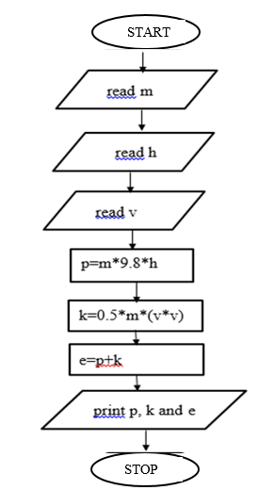

- C Program to convert Kilometers into Meters and Centimeters .

#include<stdio.h> #include<conio.h> #include<math.h> int main()
{
float Centimeter, Meter, Kilometer;
printf("\n Please Enter the Length in Kilometers (km) : ");
scanf("%f", &Kilometer);
Meter = Kilometer * 1000.0;
Centimeter = Kilometer * 100000.0;
printf("\n %.2f Kilometers = %.2f Meters", Kilometer, Meter);
printf("\n %.2f Kilometers = %.2f Centimeters", Kilometer, Centimeter);
return 0;
}

SAMPLE OUTPUT:

Please Enter the Length in Kilometers(km): 5.25
5.25 Kilometers = 5250.00 Meters
5.25 Kilometers = 525000.00 Centimeters

Algorithm

Step 1: START
Step 2: [Enter length in kilometers] read kilometer
Step 3: [convert to meter] Meter = Kilometer * 1000.0
Step 4: [convert to centimeter] Centimeter = Kilometer * 100000.0
Step 5: [Print the result] print meter and kilometer
Step 6: STOP
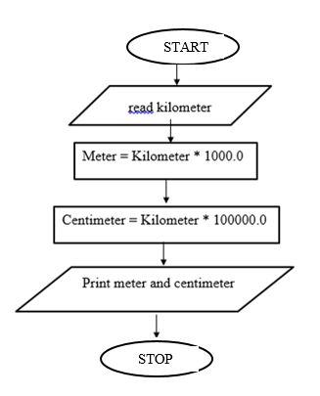

C Program To Check the Given Character is Lowercase or Uppercase or Special Character.

#include<stdio.h>
int main()
{
char ch;
printf("Enter a character:");
scanf("%c",&ch);
if(ch>='a' && ch<='z')
printf("The character is lower case");
else if(ch>='A' && ch<='Z')
printf("The character is upper case");
else if(ch>='0' && ch<='9')
printf("The character is number");
else
printf("It is a special character");
}

Sample Output

Enter a character:%
It is a special character

Enter a character:b
The character is lower case

ALGORITHM

Step 1: Start
Step 2: [read the character] read ch
Step 3: if ch>='a' && ch<='z'
print “The character is lower case “
Step 4: else if ch>='A' && ch<='Z'
print "The character is upper case"
Step 5: else if ch>='0' && ch<='9'
print "The character is number"
Step 6: else print "It is a special character"
Step 7: Stop
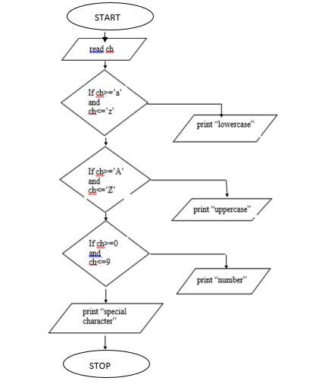

- Program to balance the given Chemical Equation values x, y, p, q of a simple chemical equation of the type: The task is to find the values of constants b1, b2, b3 such that the equation is balanced on both sides and it must be the reduced form.

#include<stdio.h>
int gcd(int a, int b)
{
if (b == 0)
return a;
return gcd(b, a % b);
}
void main()
{
int x, y, p, q,b1,b2,b3;
printf("enter the values for x, y, p and q\n");
scanf("%d %d %d %d",&x,&y,&p,&q);
if (p % x == 0 && q % y == 0)
{
b1 = p / x;
b2 = q / y;
b3 = 1;
}
else
{
p = p * y;
q = q * x;
b3 = x * y;

int temp = gcd(p, gcd(q, b3));

b1 = p / temp;
b2 = q / temp;
b3 = b3 / temp;
}
printf("b1=%d b2=%d b3=%d",b1,b2,b3);
}

SAMPLE OUTPUT:
enter the values for x, y, p and q
2
2
2
1
b1=2 b2=1 b3=2

Algorithm
Step 1: Start
Step 2: [Input the values of x,y,p and q] read x, y, p and q
Step 3: if p % x = 0 and q % y = 0
b1 = p / x,
b2 = q / y
b3 = 1
else
temp = gcd(p, gcd(q, b3))
b1 = p / temp;
b2 = q / temp;
b3 = b3 / temp;
[end if]
Step 4: print b1,b2,b3
Step 5: Stop

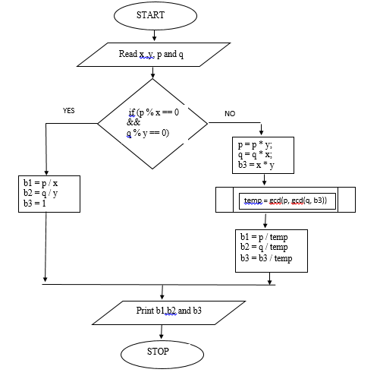

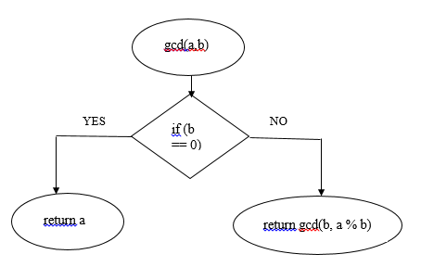

- Implement Matrix multiplication and validate the rules of multiplication.
#include <stdio.h> #include<conio.h> void main()
{
int a[10][10],b[10][10],c[10][10];
int m,n,p,q,i,j,k; clrscr();
printf("\n Enter the order of the matrix A :"); scanf("%d%d",&m,&n);
printf("\n Enter the order of the matrix B :"); scanf("%d%d",&p,&q);
if(n==p)
{
printf("\n Enter the elements of matrix A \n"); for(i = 0 ; i < m ; i++)
{
for(j = 0 ; j < n ; j++) scanf("%d",&a[i][j]);
}
printf("\n Enter the elements of matrix B \n"); for(i = 0 ; i < p ; i++)
{
for(j = 0 ; j < q ; j++) scanf("%d",&b[i][j]);
}
for(i = 0 ; i < m ; i++)
{
for(j = 0 ; j < q ; j++)
{
c[i][j]=0;
for(k = 0 ; k < n ; k++) c[i][j] += a[i][k] * b[k][j];
}
}
printf("\n MATRIX A \n"); for(i = 0 ; i < m ; i++)
{
for(j = 0 ; j < n ; j++)
{
printf(" %d \t", a[i][j]);
}

printf("\n");
}
printf("\n MATRIX B \n"); for(i = 0 ; i < p ; i++)
{
for(j = 0 ; j < q ; j++)
{
printf(" %d \t", b[i][j]);
}
printf("\n");
}
printf("\n MATRIX C \n"); for(i = 0 ; i < m ; i++)
{
for(j = 0 ; j < q ; j++)
{
printf(" %d \t", c[i][j]);
}
printf("\n");
}
}
else
printf("Matrix A & B is not multiplicable");

getch();
}

SAMPLE OUTPUT:

Enter the order of the matrix A :2 2
Enter the order of the matrix B :2 2 Enter the elements of matrix A
1 2
3 4

Enter the elements of matrix B 1 2
1 2

MATRIX A 1 2
3 4

MATRIX B 1 2
1 2

MATRIX C 3 6
7 14

Algorithm

Step1: Start
Step2: read matrix A order m and n Step3: read matrix B order p and q Step4: if n not equal to p print “multiplication not possible” goto Step11. Otherwise goto Step5
Step5: read the elements of matrix A, using loops for i=0 to m-1 for j= to n-1
Step6: read the elements of matrix B, using loops for i=0 to p-1 for j=0 to q-1
Step7: calculate resultant matrix C using nested loops for i 0 to m-1 for j 0 to q-1
c[i][j]=0 c[i][j]=c[i][j]+a[i][k]*b[k][j]
Step8: print elements of matrix A using nested loops for i to m-1
for j 0 to n-1
Step9: print elements of matrix B using nested loops for i for j to p-1 to q-1
Step 10: print elements of matrix C using nested loops for i 0 to n-1

for j 0 to q-1 Step 11: Stop

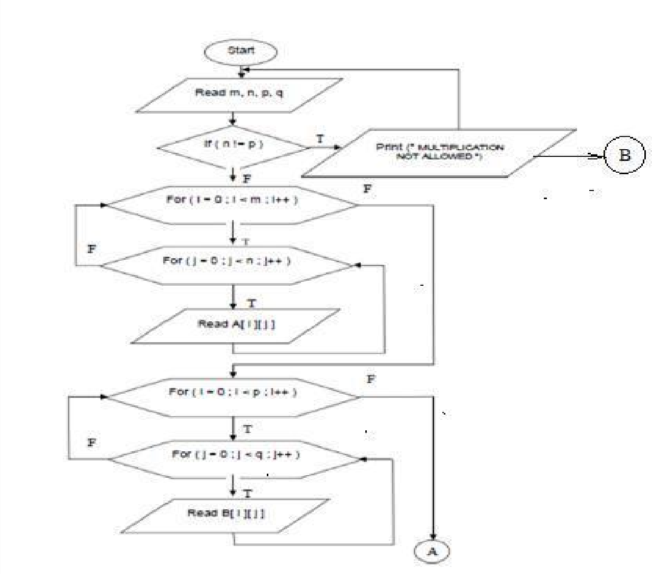

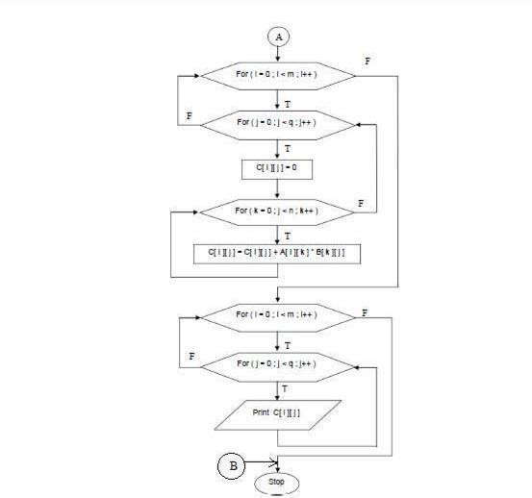

Flowchart

- Compute sin(x)/cos(x) using Taylor series approximation. Compare your result with the built-in library function. Print both the results with appropriate inferences.

#include<stdio.h> #include<stdlib.h> #include<math.h> #define pi 3.142 void main()
{
int degree,i;
float x,nume,denom,sum=0,term; clrscr();
printf("enter the value of degree\n"); scanf ("%d", &degree); x=(degree*pi)/180;
nume=x; denom=1; i=2;

do
{
term=nume/denom; nume= -nume*x*x; denom=denom*i*(i+1); sum=sum+term;
i=i+2;
}
while(fabs(term)>0.00001);

printf("sin(%d)=%f without using built in function \n",degree,sum); printf("sin(%d)=%f using built in function \n",degree,sin(x)); getch();
}

SAMPLE OUTPUT:

enter the value of degree
30
sin(30)=0.500059 without using built in function sin(30)=0.500059 using built in function

enter the value of degree 60
sin(60)=0.866093 without using built in function sin(60)=0.866093 using built in function

Algorithm
Step 1: Start
Step 2: initialize sum to 0
Step 3: read the value of degree Step 4: calculate x=(degree*PI)/180 Step 5: initialize nume to x
denom to 1 i=2
Step 6: do term=nume/denom; nume=nume*x*x; denom=denom*i*(i+1) sum=sum+term i=i+2 while(fabs(term)>0.00001)
Step 7: print (sin(x) without built-in function) Step 8: print sin(x) using built-in function Step 9: Stop.

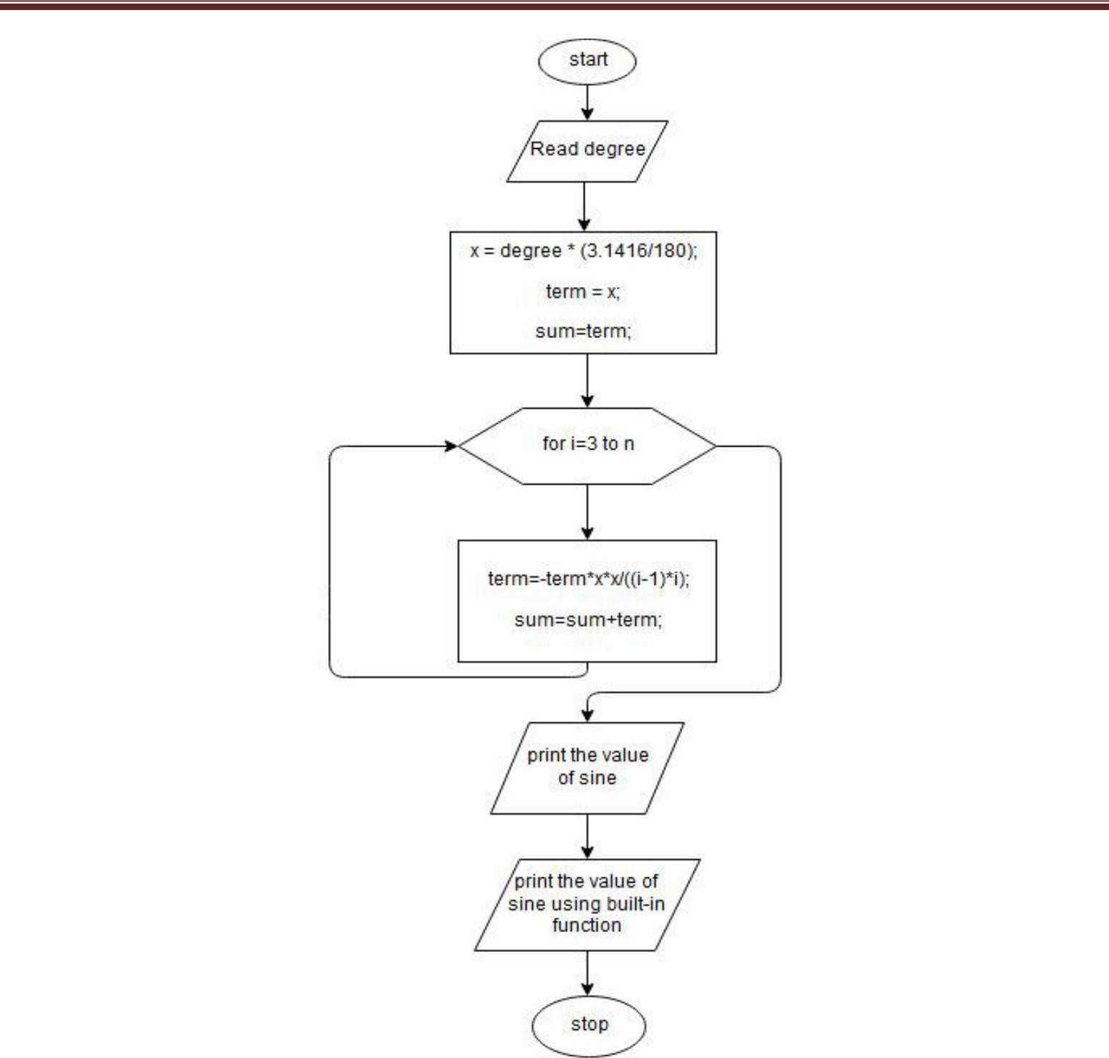

Flowchart

- Write functions to implement string operations such as compare, concatenate, string length. Convince the parameter passing techniques.
#include<stdio.h> int slength(char str[])
{
int len; //int len=0;
for(len=0;str[len]!='\0';len++); //while(str[len]!='\0') return len; //len++;
//return len;
}

void scompare(char str1[],char str2[])
{
int i,flag=0;
if(slength(str1) != slength(str2)) flag=1;
else
for(i=0;i< slength(str1);i++) if(str1[i]!=str2[i])
{
flag=1; break;
}
if(flag==1)
printf("\nStrings are Not Equal\n"); else
printf("\nStrings are Equal.\n");
}

void sconcat(char str1[],char str2[],char conc[])
{
int i,j;
for(i=0; i< slength(str1);i++)
conc[i]=str1[i];
for(j=0; j<slength(str2);j++) conc[i++]=str2[j]; conc[i]='\0';
}

void main()
{
char str1[50],str2[50],conc[100]; int len,choice;
clrscr(); while(1)
{
printf("\n\n\nMAIN MENU\n");
printf("\n1.Compare strings\n2.Concatenate Strings\n3.String Length\n4.Exit\n\n");

printf("\nEnter your choice:"); scanf("%d",&choice); fflush(stdin);
switch(choice)
{
case 1:printf("\nEnter the First string:"); gets(str1);
printf("\nEnter the Second string:"); gets(str2);
scompare(str1,str2); break;
case 2:printf("\nEnter the First string:"); gets(str1);
printf("\nEnter the Second string:"); gets(str2);
sconcat(str1,str2,conc);
printf("\nConcatenated string is:%s\n\n",conc); break;
case 3:printf("\nEnter the String:"); gets(str1);
len=slength(str1);
printf("\n\nThe Length of the string is: %d\n\n",len); break;
case 4:printf("\nExiting the program...!!!"); exit(0);
default: printf("\nInvalid choice..!!!");
} // End of Switch

}} //End of While

SAMPLE OUTPUT:

MAIN MENU

1.Compare strings 2.Concatenate Strings 3.String Length 4.Exit

Enter your choice:1

Enter the First string:saptha Enter the Second string:giri Strings are Not Equal

MAIN MENU

1.Compare strings 2.Concatenate Strings 3.String Length 4.Exit

Enter your choice:4 Exiting the program...!!!

Algorithm:

Step 1. [Initialise] Start
Step 2. Input the two strings] read s1, s2
Step 3. [perform two string compare using a function] Call the function Str2cmp(s1,s2) Step 4. [perform two string concatenation] Call the function Str2cat(s1,s2)
Step 5. Find the length of two string using a function] Call the function length(s1), length(s2) Step 6. [Finished] Stop

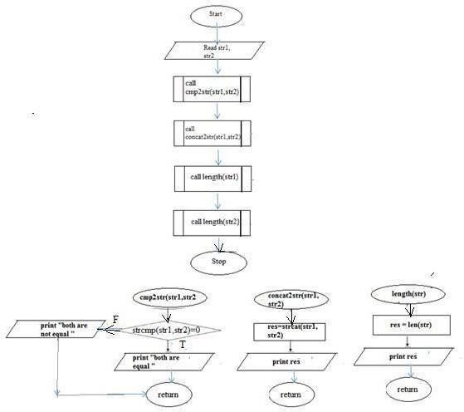

Flowchart

- Sort the given set of N numbers using Bubble sort.
#include <stdio.h> #include<conio.h> void main()
{
int n,i,j,a[10],b[10],temp; clrscr();
printf("\n Enter the no. of elements : "); scanf("%d",&n);
printf("\n Enter %d elements\n",n); for(i = 0 ; i < n ; i++)
{
scanf("%d",&a[i]); b[i]=a[i];
}
for(i = 0 ; i < n-1 ; i++)
{
for(j = 0 ; j < n-i; j++)
{
if(a[j] > a[j+1])
{
temp = a[j]; a[j] = a[j+1]; a[j+1] = temp;
}
}
}
printf("\nThe original elements are\n "); for(i = 0 ; i < n ; i++)
printf("%d \n",b[i]);
printf("\nThe Sorted elements are\n ");
for(i = 0 ; i < n ; i++) printf("%d \n",a[i]); getch();
}

SAMPLE OUTPUT:

Enter the no. of elements : 5

Enter 5 elements
12 45 76 3 0

The original elements are 12
45
76
3
0

The Sorted elements are 0
3
12
45
76

Algorithm

Step1: Start
Step2: Read the value of n
Step3: Read the array elements using loop
for i to n-1
Step4: Repeat steps using nested loop Step5: for i=0 to n-1 for j=0 to n-i
if(a[j] > a[j+1]) temp = a[j]; a[j] = a[j+1]; a[j+1] = temp; Step6: print the sorted elements using loop for i=0 to n-1
Step7: Stop

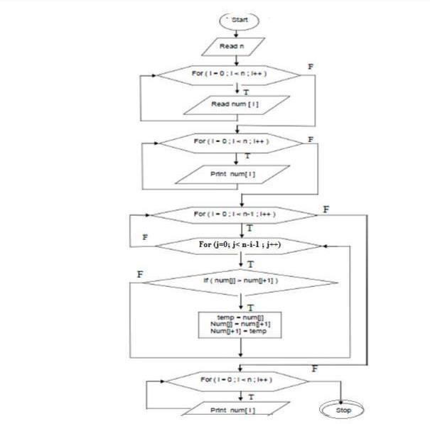

SAPTHAGIRI COLLEGE OF ENGINEERING DEPARTMENT OF COMPUTER SCIENCE AND ENGINEERING

Implement structures to read, write, and compute average- marks and the students scoring above and below the average marks for a class of N students. #include<stdio.h>
#include<string.h> struct student
{
int rnumber; char name[20]; int marks;
char grade;
}stud[60];

void main()
{
int i,n;
float sum=0,avg=0; clrscr();
printf("Enter the number of students"); scanf("%d",&n);
printf("\nEnter the roll number, Name , Marks and Grade of the student \n"); for(i=1;i<=n;i++)
{
printf("\nStudent %d details\n",i);
scanf("%d",&stud[i].rnumber);
scanf("%s",stud[i].name);
scanf("%d",&stud[i].marks); fflush(stdin); stud[i].grade=getchar(); sum+=stud[i].marks;
}
avg=sum/n;
printf("\n Avg marks is %f",avg); printf("\nStudent Details are:"); printf("\nRoll_number\tName\tMarks\tGrade"); for(i=1;i<=n;i++)
printf("\n%d\t\t%s\t%d\t%c\t",stud[i].rnumber,stud[i].name,stud[i].marks,stud[i].grade); printf("\n Details of Students who scored Above avarage Marks\n"); printf("\nRoll_number\tName\tMarks\tGrade\n");
for(i=1;i<=n;i++)
{
if(stud[i].marks >= avg) printf("\n%d\t\t%s\t%d\t%c\t",
stud[i].rnumber,stud[i].name,stud[i].marks,stud[i].grade);
}
printf("\n Details of Students who scored Below avarage Marks\n"); printf("\nRoll_number\tName\tMarks\tGrade\n");

for(i=1;i<=n;i++)
{
if(stud[i].marks < avg) printf("\n%d\t\t%s\t%d\t%c\t",
stud[i].rnumber,stud[i].name,stud[i].marks,stud[i].grade);
}
getch();
}

SAMPLE OUTPUT:

Enter the number of students 3
Enter the roll number, Name , Marks and Grade of the student Student 1 details
10
pradeep 50
A

Student 2 details
15
manju 60
B

Student 3 details
20
govind 70
A

Avg marks is 60.000000 Student Details are:
Roll_number Name Marks Grade
10 pradeep 50 A
15 manju 60 B
20 govind 70 A
Details of Students who scored Above avarage Marks Roll_number Name Marks Grade
15 manju 60 B
20 govind 70 A
Details of Students who scored Below avarage Marks Roll_number Name Marks Grade
10 pradeep 50 A

Algorithm

Step 1: Start
Step 2: Define the structure with required variables Step 3: Read the value of n
Step 4: Read the student details using loop for i= 1 to n read rnumber, name marks, grade Step 5: Calculate sum Sum=sum+marks
Step 6: Calculate average Average=sum/n Step 7: print the result using loop for i=1 to n
print rnumber,name,marks,grade,average Step 8: for=1 to n
if(marks>=average)
print rnumber,name,marks and grade Step 9: if(marks<=average)
print rnumber, name, marks and grade Step 10: Stop
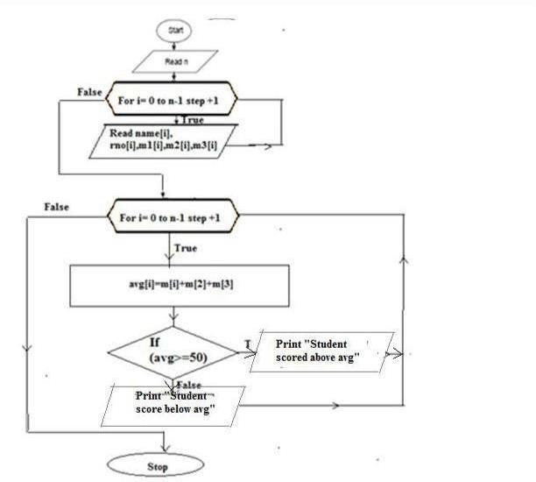

Flowchart

Develop a program using pointers to compute the sum, mean and standard deviation of all elements stored in an array of n real numbers.
#include<stdio.h> #include<conio.h> #include<math.h> void main()
{
float a[10],*ptr,mean,std,sum=0,sumstd=0; intn,i;
clrscr();
printf("enter the no of elements\n"); scanf("%d",&n);
printf("enter the array elemnts\n"); for(i=0;i<n;i++) scanf("%f",&a[i]);
ptr=a; for(i=0;i<n;i++)
{
sum=sum+*ptr; ptr++;
}
mean=sum/n; ptr=a; for(i=0;i<n;i++)
{
sumstd=sumstd+pow((*ptr-mean),2);
ptr++;
}
std=sqrt(sumstd/n); printf("sum=%f\t",sum); printf("mean=%f\t",mean); printf("standard deviation=%f\t",std); getch();
}

SAMPLE OUTPUT:
Enter the no of elements 5
Enter the array elements 2
3
4
5
6
Sum=20.000 Mean=4.000 Standard deviation=1.414

Algorithm

Step 1. [Initialise] Start Step 2. [Input the elements] Read n, a[i] Step 3. [Initialize]
sum=0, sumstd=0
Step 4. [Compute sum, mean, standard deviation] Ptr=a For i = 0 thru n in steps of 1 sum=sum+*ptr , Ptr++ , mean=sum/n , Ptr=a For i= 0 thru n in steps of 1 sumstd=sumstd+pow((*ptr-mean),2)
Ptr++
Step 5 . std=sqrt(sumstd/n)
Step 6. [Output sum, mean and standard deviation] Print sum, mean, std Step 7. [ Finished ] Stop
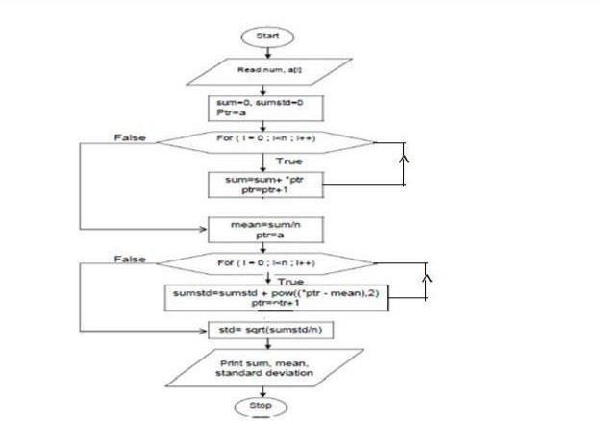

Implement Recursive functions for Binary to Decimal Conversion.
#include<stdio.h> #include <math.h>
int binarytodecimal(int binarynum)
{
if(!(binarynum/10)) return binarynum;
return(binarynum%10 + binarytodeciamal(binarynum/10)*2);
}
int main()
{
int binarynum;
printf(“enter the binary number\n”); scanf(“%d”,&binarynum);
printf(“equivalent decimal number is %d”,binarytodecimal(binarynum));
return 0;
}

SAMPLE OUTPUT:

Enter The Number of Digits in Binary Number: 3

Enter Binary Digits One After Another: 1
1
1

Decimal Equivalent of Binary Number: 7

Enter The Number of Digits in Binary Number: 4 Enter Binary Digits One After Another:
1
0
1
0

Decimal Equivalent of Binary Number: 10

Algorithm

Step 1: Start
Step 2: Take input
Enter binary num Step 3: Function call

Step 4: Receiver return value
Print “equivlant decimal num=%d” Step 5: Stop
Function definition
Step 1: Receive the value from actual Parameter to formal parameter
Step 2: If (! (Binary num/10)) return (binary num)
return (binary num%10+binary to decimal(binary num/10)*2); Step 3: End if
